**Internet Protocols - Public and Private IP addresses**

## Task 1: Investigate the customer's environment

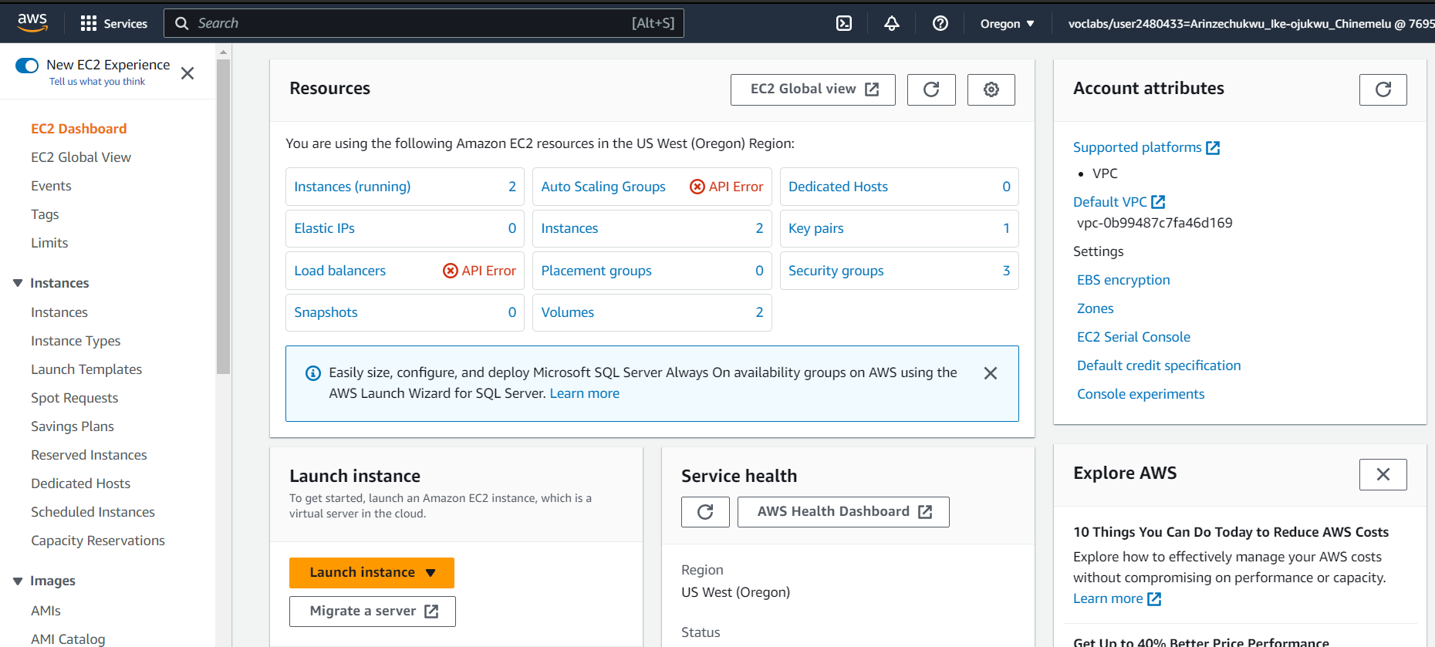

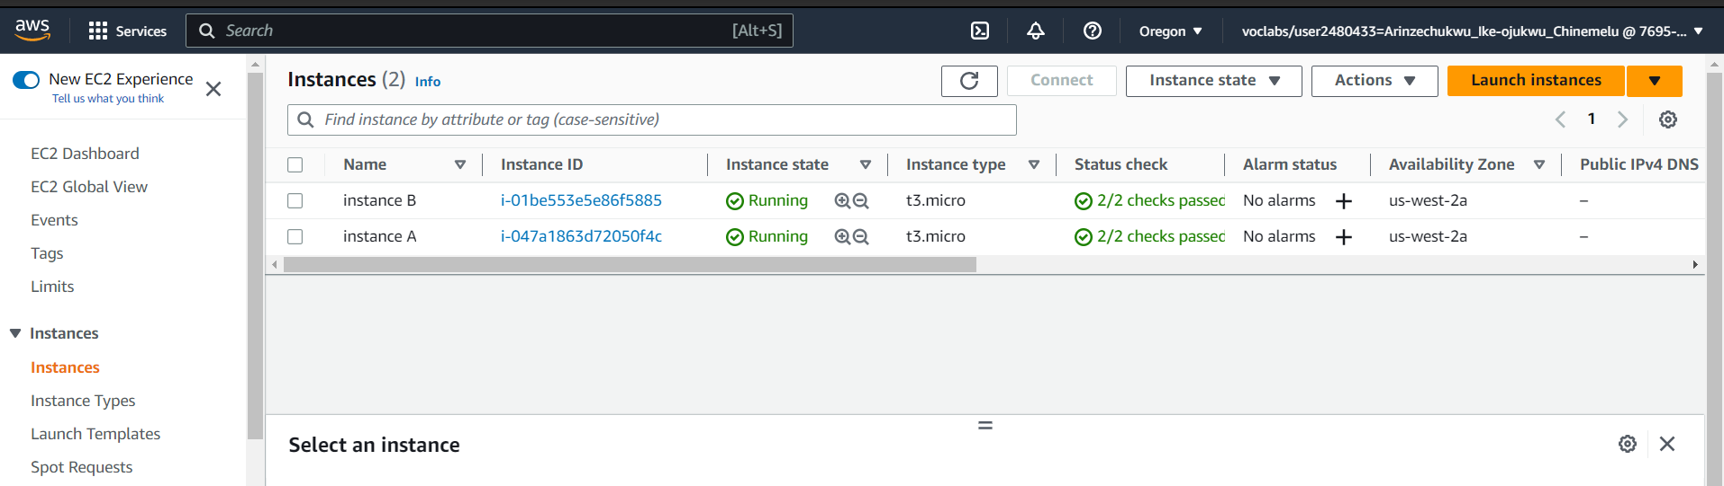

10.0.10.122 -a

10.0.10.98-b  34.221.36.92 pu

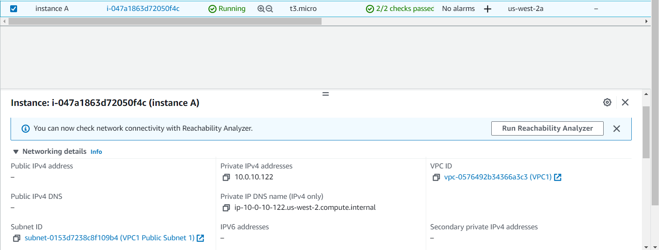

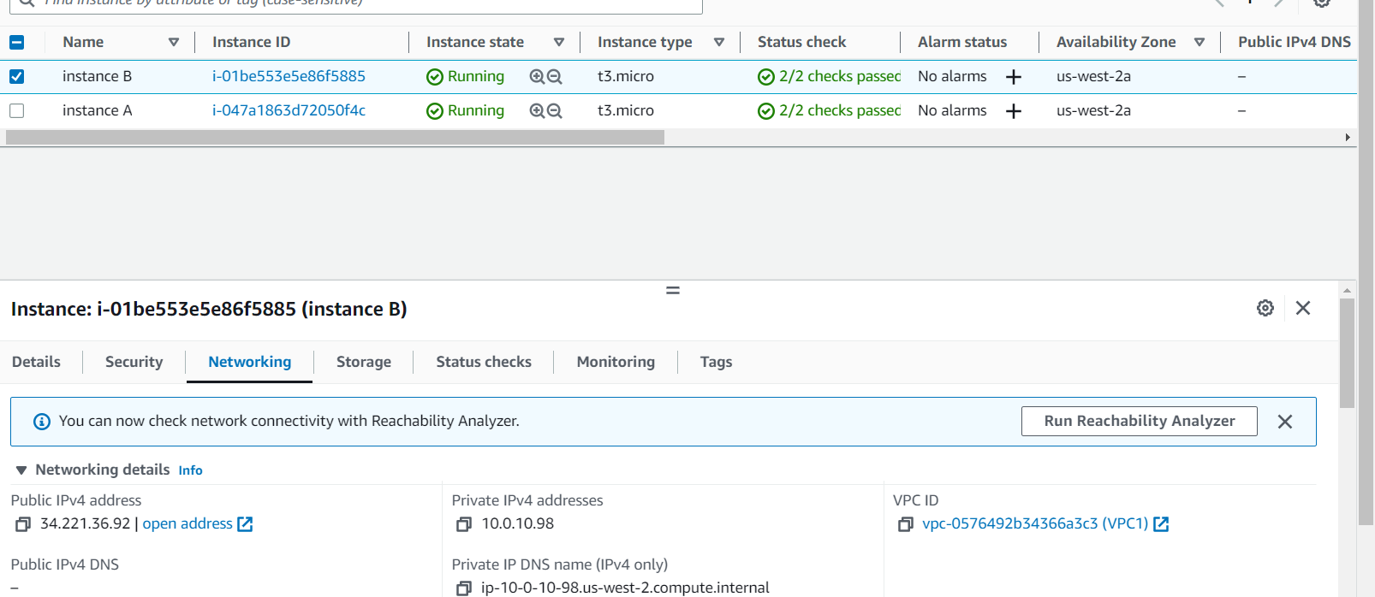

**Task 2: Use SSH to connect to an Amazon Linux EC2 instance**

### Windows Users: Using SSH to Connect

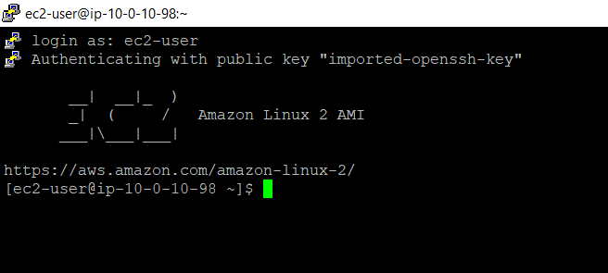

## Task 3: Send the Response to the customer (group activity)

## Lab Complete

